

AP® Physics C
1981 Free Response Questions

The materials included in these files are intended for use by AP teachers for course and exam preparation in the classroom; permission for any other use must be sought from the Advanced Placement Program®. Teachers may reproduce them, in whole or in part, in limited quantities, for face-to-face teaching purposes but may not mass distribute the materials, electronically or otherwise. These materials and any copies made of them may not be resold, and the copyright notices must be retained as they appear here. This permission does not apply to any third-party copyrights contained herein.

These materials were produced by Educational Testing Service® (ETS®), which develops and administers the examinations of the Advanced Placement
Program for the College Board. The College Board and Educational Testing Service (ETS) are dedicated to the principle of equal opportunity, and their
programs, services, and employment policies are guided by that principle.

The College Board is a national nonprofit membership association dedicated to preparing, inspiring, and connecting students to college and opportunity.
Founded in 1900, the association is composed of more than 4,200 schools, colleges, universities, and other educational organizations. Each year, the
College Board serves over three million students and their parents, 22,000 high schools, and 3,500 colleges, through major programs and services in
college admission, guidance, assessment, financial aid, enrollment, and teaching and learning. Among its best-known programs are the SAT®, the
PSAT/NMSQT®, and the Advanced Placement Program® (AP®). The College Board is committed to the principles of equity and
excellence, and that commitment is embodied in all of its programs, services, activities, and concerns.

APIEL is a trademark owned by the College Entrance Examination Board. PSAT/NMSQT is a registered trademark jointly owned by the College Entrance Examination Board and the National Merit Scholarship Corporation. Educational Testing Service and ETS are registered trademarks of Educational Testing Service.
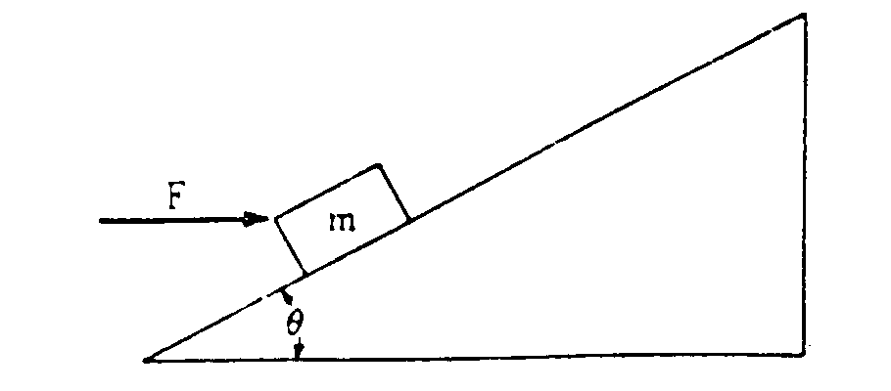
1981M1. A block of mass m, acted on by a force of magnitude F directed horizontally to the right as shown above, slides up an inclined plane that makes an angle θ with the horizontal. The coefficient of sliding friction between the block and the plane is μ.
a. On the diagram of the block below, draw and label all the forces that act on the block as it slides up the plane.
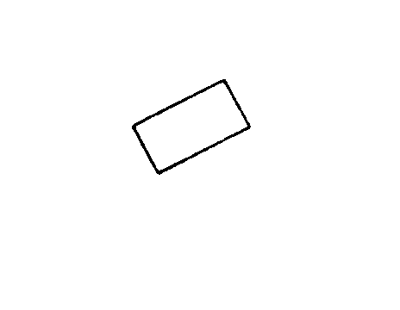
b. Develop an expression in terms of m, θ, F, μ, and g, for the block’s acceleration up the plane.
c. Develop an expression for the magnitude of the force F that will allow the block to slide up the plane with constant velocity. What relation must θ and μ satisfy in order for this solution to be physically meaningful?

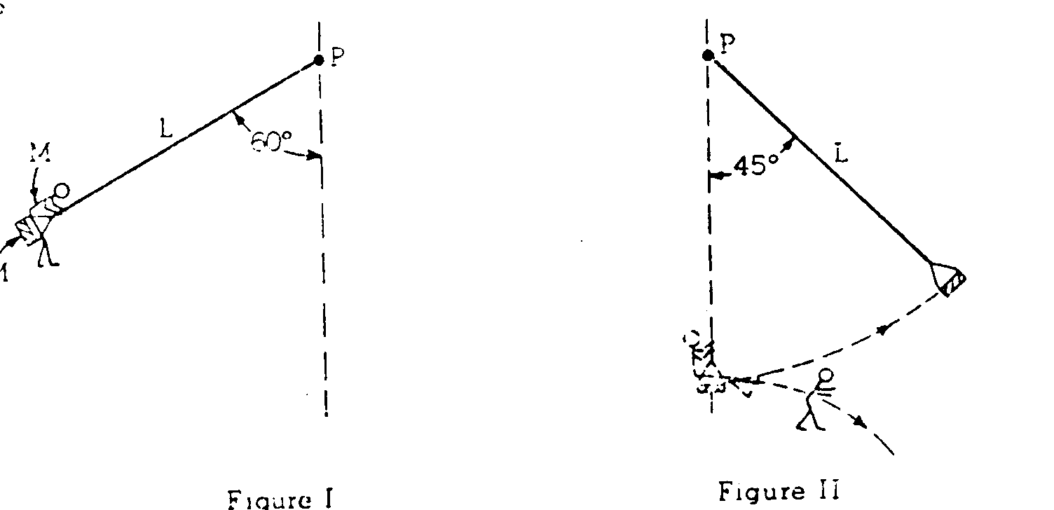
1981M2. A swing seat of mass M is connected to a fixed point P by a massless cord of length L. A child also of mass M sits on the seat and begins to swing with zero velocity at a position at which the cord makes a 60° angle with the vertical is shown in Figure I. The swing continues down until the cord is exactly vertical at which time the child jumps off in a horizontal direction. The swing continues in the same direction until its cord makes a 45° angle with the vertical as shown in Figure II: at that point it begins to swing in the reverse direction. With what velocity relative to the ground did the child leave the swing? (cos 45° = sin 45° = 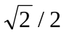, sin 30° = cos 60° = 1/2, cos 30° = sin 60° = 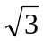/2)

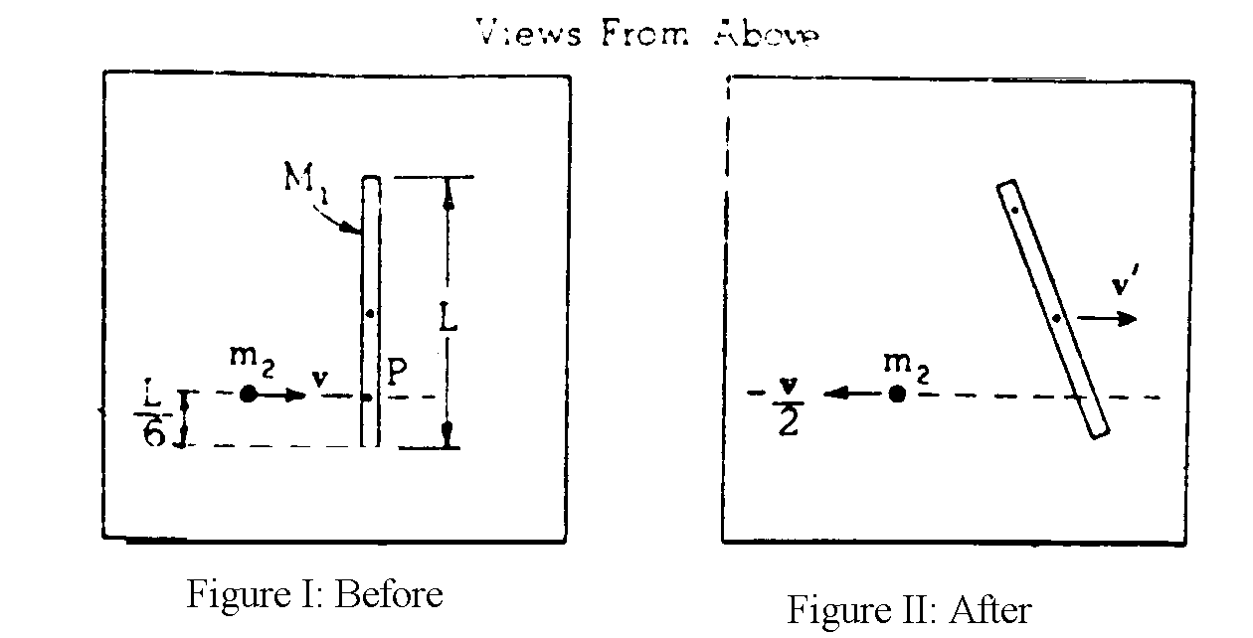
1981M3. A thin, uniform rod of mass M₁ and length L , is initially at rest on a frictionless horizontal surface. The moment of inertia of the rod about its center of mass is M₁L²/12. As shown in Figure I, the rod is struck at point P by a mass m₂ whose initial velocity v is perpendicular to the rod. After the collision, mass m₂ has velocity -½v as shown in Figure II. Answer the following in terms of the symbols given.
a. Using the principle of conservation of linear momentum, determine the velocity v’ of the center of mass of this rod after the collision.
b. Using the principle of conservation of angular momentum, determine the angular velocity ω of the rod about its center of mass after the collision.
- Determine the change in kinetic energy of the system resulting from the collision.
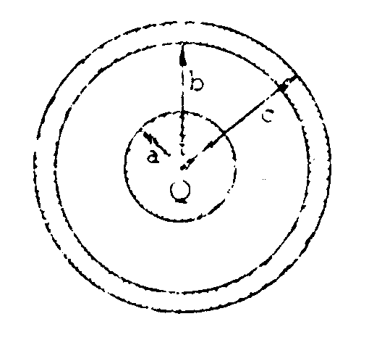
1981E1. A conducting sphere of radius a and charge Q is surrounded by a concentric conducting shell of inner radius b and outer radius c as shown above. The outer shell is first grounded; then the grounding wire is removed.
a. Using Gauss’s law, determine the electric field in the region a < r < b, where r is the distance from the center of the inner sphere.
b. Develop an expression for the capacitance C_{o} of the system of the two spheres.
A liquid dielectric with a dielectric constant of 4 is then inserted in the space between the conducting spheres and the shell, filling half of the space as shown below.
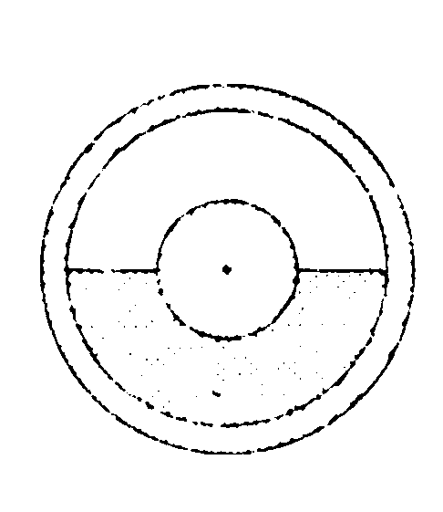
b. Determine the capacitance C of the system in terms of C_{o.}

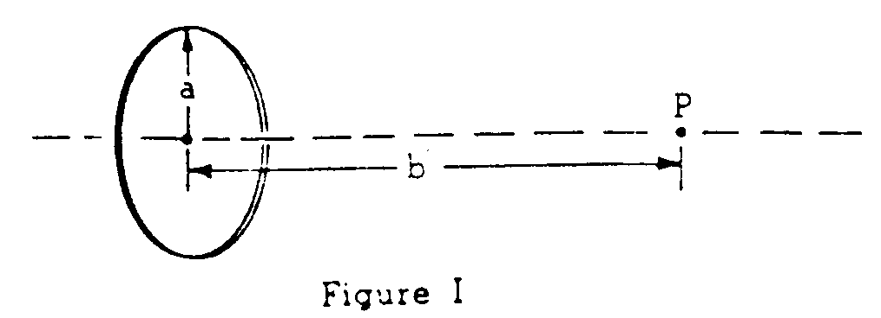
1981E2. A ring of radius a has a total charge +Q distributed uniformly around its circumference. As shown in Figure I, the point P is on the axis of the ring at a distance b from the center of the ring.
a. On Figure I above, show the direction of the electric field at point P.
b. Determine the magnitude of the electric field intensity at point P.
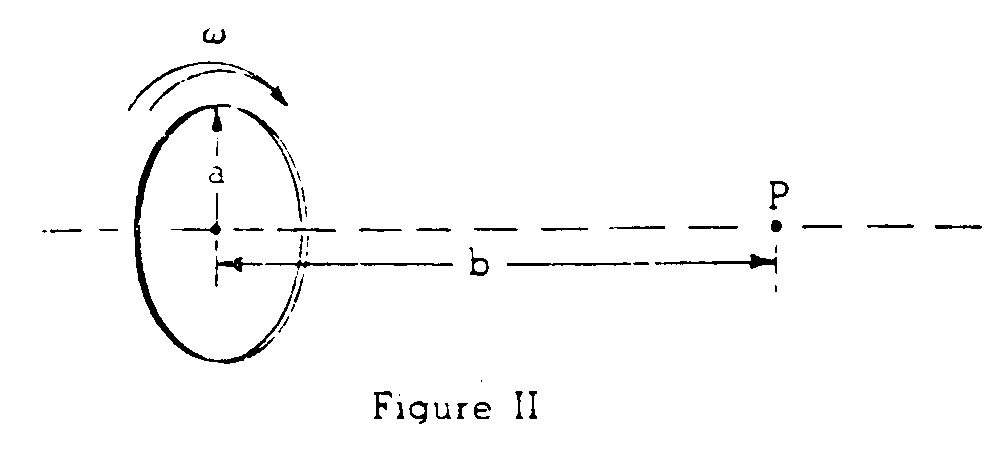
As shown in Figure II, the ring is now rotated about its axis at a uniform angular velocity ω in a clockwise direction as viewed from point P. The charge moves with the ring.
c. Determine the current of this moving charge.
d. on Figure II above, draw the direction of the magnetic field at point P.
e. Determine the magnitude B of the magnetic field at point P.
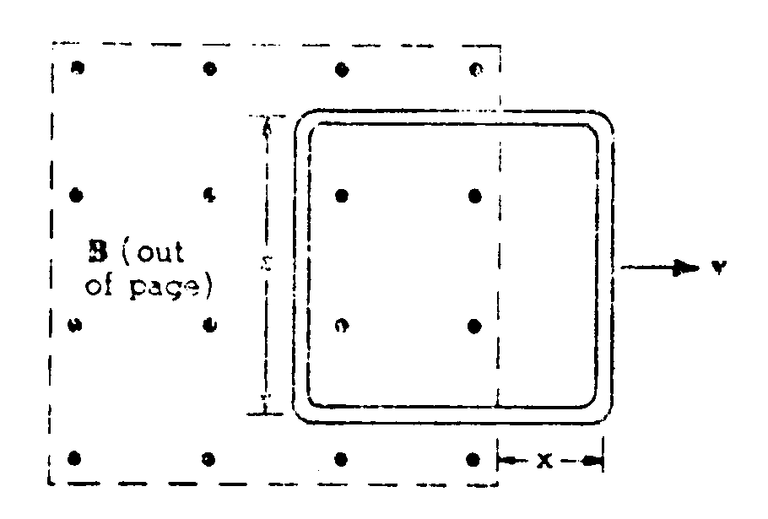
1981E3. A square loop of wire of side s and resistance R is pulled at constant velocity v out of a uniform magnetic field of intensity B. The plane of the loop is always perpendicular to the magnetic field. After the leading edge of the loop has passed the edge of the B field as shown in the figure above, there is an induced current in the loop.
a. On the figure above, indicate the direction of this induced current.
b. Using Faraday’s law of induction, develop an expression for the induced emf ε in the loop.
c. Determine the induced current I in the loop.
d. Determine the power required to keep the loop moving at constant velocity.

